CS20 :

HTML : HyperText Markup language.

The DOM: documents object modul is the structure of your page :

For instance :   
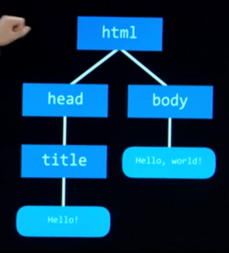

Title is hello world but title I am coming with new skills.

Src : short of source.

Alt : alternative text or a text-based representation

< img src=”C:\.....” alt=”cat example” width=”300”…>

Link:  
a tag for anchor tag / anchor link.  
Href : hypelink reference  
< a href=<https://www.youtube.com>> Open here </a>

<br> to return into a new line.  
Specifity :

1.inline

2.id

3.class

4.type

Responsive design :

Viewport / Media queries / Flexbox / Grids.

SASS: Syntactically Awesome Style Sheet.

CSS: Cascading Style Sheet